

10009257 Karavita, K V Vishmi D

10009240 Priyamali, G Darshi

10009234 Kandage,K D Nethmini R

10009046 Jayaweera, W A H M Lakshika R

10001466 Kaushalya, P H Buddhi

10009249 Senadheera, S A Saroj

Echonlabs  
strategic plan

Assignment Report on Business policy & Strategy BS401.3

Contents

Document Control 2

Document Information 2

Document History 2

Company Background 3

Executive Summary 4

Vision 4

Mission 4

Values 5

SWOT analysis of Echonlabs(Pvt) Ltd 7

Strategic Objectives 8

Business Strategies 8

Functional Strategies 10

Action Plan 11

Focus Area: Innovation / Product Growth aligned with innovativeness 11

Focus Area: People / Culture aligned with respect and employee empowerment 15

Focus Area: Processes / Operations aligned with innovativeness 19

Focus Area: Financial Growth aligned with employee empowerment 22

Focus Area: Customer Satisfaction aligned with trust 24

HR Plan 27

Company Structure 27

Focus Area: Innovation / Product Growth aligned with innovativeness 28

Focus Area: People / Culture aligned with respect and employee empowerment 30

Focus Area: Processes / Operations aligned with innovativeness 32

Focus Area: Financial Growth aligned with employee empowerment 33

Focus Area: Customer Satisfaction aligned with trust 34

Conclusion 36

References 37

# Document Control

## Document Information

|  |  |
| --- | --- |
| Information | |
| Document Id |  |
| Document Owner | S A Senadheera |
| Issue Date | 27/03/2020 |
| Last Saved Date | 27/03/2020 |
| File Name | ECHONLABS STRATEGIC PLAN |

## Document History

|  |  |  |
| --- | --- | --- |
| Version | Issue Date | Changes |
| 1.0 | 14/02/2020 | Introduction/ organizational values |
| 2.0 | 16/02/2020 | SWOT values |
| 3.0 | 23/02/2020 | Introduction/ HR plan/ organizational values |
| 4.0 | 28/02/2020 | Action Plan/ HR plan/ Executive Summery |
| 5.0 | 27/03/2020 | References/ document control/ conclusion/ content |

# Company Background

Echonlabs(Pvt) Ltd is a Tech-Startup based in Sri Lanka consisting of young Tech-Enthusiasts with amazing skills. Their motivation and passion is driven at the sight of the satisfied customers, and on how much of an impact they can make to make this world a better place, as the generation that is just stepping into the drivers' seat.

They custom-tailor solutions to improve the productivity and efficiency of the customer’s business so that customers can give both their clients and employees a better experience. Echonlabs skilled team has worked with the latest technologies to bring out the best performing solutions to their customers.

Their main products are web and mobile solutions. They help their customers to build an online presence for their customer’s business with a website or help to reach more customers with a mobile application or even help to make their customer’s business process more efficient with Echonlabs own solutions.

Currently the main clients they have is Kleenpark (pvt) Ltd, House of furniture, SensusHub (Pvt) Ltd. Echonlabs provide web and mobile solutions to those clients such as Customer relationship management systems, company websites and mobile apps.

As the main in-house products currently they are working on, they have LIMM (medical laboratory information management module), Trek mobile app (travel guiding application) and FiXar mobile and web application (service providing application).

Even though Echonlabs is a tech startup recently initiated, they work in a manner where they follow industry standards and ethics.

# Executive Summary

In this report it is studied how Echonlabs is operated via a thorough analysis of current organizational processes. SWOT analysis of the organizational is done to determine its internal strengths, weaknesses and its external opportunities and threats. The aim of this SWOT analysis is to improve on the weak areas, eliminate threats, grasp opportunities and fuel its strengths. Objective analysis is done to identify the organization's actions to strengthen its core values such as Employee empowerment, Knowledge sharing and Innovation, Trust, Respect. The strategies are divided into two categories which is also ordered in a hierarchical manner. First attempt to achieve organizational values is to identify suitable business strategies. Then to follow up with the identified business strategies a skillful manager would select plausible functional strategies. Action plan is the detailed description about the process which a person should carry out in order to achieve the functional strategies. In this actional plan it includes the objective, date of start and finish, personnel who are responsible and the people who are necessary to carry it out. In an HR plan it is given the optimal hierarchy of organizational roles in order to carry out the action plan.

# Vision

Connect everyone to solutions that increase productivity and efficiency, through innovative solutions.

# Mission

Provide low-cost premium solutions for businesses to build their online presence and to improve their workflow.

# Values

1. Employee empowerment

Inspiring employees while giving freedom and authority to adapt and respond in real-time with solutions to deliver extraordinary results.

* Delegate with the intent to grow and develop the capabilities and responsibilities of our employees
* Setting clear expectations, and giving employees permission to make decisions while ensuring the decisions are in line with company goals.
* Giving constructive feedback and being specific about the actions or attitudes that need to be repeated and the impact it had on others.
* Include employees’ in decision-making and goal-setting and hearing their ideas and input.
* Communicating the vision of the organization and how a team and its individuals contribute to that vision.

1. Knowledge sharing and Innovation

Transformation of collective individual knowledge to organizational knowledge without the existence of orphaned knowledge and knowledge depreciation to result in the enrichment of organizational effectiveness.

* Use of clear and transparent means of communication and allowing employees can freely express their individualistic ideas and might contribute to future success.
* Engaging People via Conversations by creating an opportunity where people can meet and communicate freely can lead to meaningful peer-peer conversations.
* Creating a Knowledge Base using dedicated knowledge sharing platforms to assist in eradicating communal nervousness associated with sharing information, allow employees to easily identify experts so as to search for relevant knowledge, and encourage solidarity among employees.
* Enabling Open Door Policy that helps in breaking barriers among employees and brings them closer intellectually as well as emotionally.
* Improving intrapreneurship for employees to bring their ideas to the company where they are employed.

1. Trust

Developing meaningful relationships to achieve tangible and intangible benefits to the organization.

* Setting Realistic Goals that reflects employee’s competency level and allowing listening to their concerns.
* Accountability, leading by example and holding every employee disregarding their designation to the same standards.
* Being Direct, Honest, and Consistent to achieve expected results.
* Eliminating micromanaging that is rooted in distrust.

1. Respect

Thinking Green, honor diversity and treat everyone with dignity in order to achieve growth and profitability.

* Use cloud computing to virtualize resources in order to save energy and allow resources to be sustainable.
* Algorithmic efficiency, using efficient algorithms to be used as best practices to use less computer resources and ultimately use less energy thus enabling lesser carbon footprint.
* Recognition and appreciation, enabling opportunities to show appreciation and recognize employee contributions often.
* Focus on diversity, having ways to encourage education and differences in celebrating employees’ heritage or nationality and tradition. E.g cultural events.
* Handle bullying/harassment quickly and effectively, making questionable behavior not tolerating and taking actions against which are within organizational standards and Eliminate favoritism

# SWOT analysis of Echonlabs(Pvt) Ltd

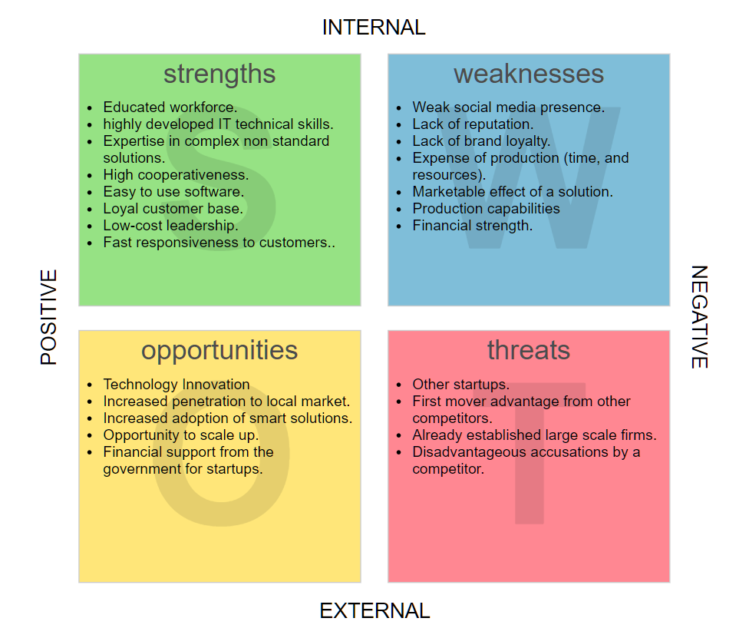

# Strategic Objectives

Since Echonlabs is a relatively new IT startup, it is identified as a “Single-Business Company” where it only provides IT services to its customers. Thus only the Business strategies and functional strategies will be considered.

## Business Strategies

* Cost Leadership aligned with respect and trust – Organizations compete for a broad client based on price. The price depends on internal efficiency in order to obtain a margin that maintains the average returns and cost to the customer so that customers can purchase the product / service. It works well when the product / service is standardized, it can contain general goods acceptable to many customers, and can offer the lowest price. Continuous efforts to reduce costs relative to competitors are necessary in order to be a successful cost customer.
  + Porter's 5 Forces Model
    - Rivalry – Competitors are likely to avoid a price war, since the low cost firm will continue to earn profits after competitors compete away their profits.
    - Customers – Powerful customers that force firms to produce service at lower profits may exit the market rather than earn below average profits leaving the low cost organization in a monopoly position. Buyers then lose much of their buying power.
    - Suppliers – Cost leaders are able to absorb greater price increases before it must raise price to customers.
    - Entrants – Low cost leaders create barriers to market entry through its continuous focus on efficiency and reducing costs.
    - Substitutes – Low cost leaders are more likely to lower costs to entice customers to stay with their product, invest to develop substitutes, purchase patents.
  + How to Obtain a Cost Advantage
    - Determine and Control Cost
    - Reconfigure the Value Chain as Needed
  + Risks
    - Technology
    - Imitation
    - Tunnel Vision
* Differentiation aligned with trust and innovation - Customer value is provided through unique features and features of the enterprise's products, rather than the lowest price. This is done through high quality, features, high customer service, rapid product innovation, advanced technology features, image management, etc
  + Create Value by:
    - Lowering Buyers' Costs – Higher quality means less breakdowns, quicker response to problems.
    - Raising Buyers' Performance – Buyer may improve performance, have higher level of enjoyment.
    - Sustainability – Creating barriers by perceptions of uniqueness and reputation, creating high switching costs through differentiation and uniqueness.
  + Risks of Using a Differentiation Strategy
    - Uniqueness
    - Imitation
    - Loss of Value
  + Porter's Five Forces Model – Effective differentiators can remain profitable even when the five forces appear unattractive.
    - Rivalry – Brand loyalty means that customers will be less sensitive to price increases, as long as the firm can satisfy the needs of its customers.

Suppliers – Because differentiators charge a premium price they can more afford to absorb higher costs and customers are willing to pay extra too.

## Functional Strategies

* Focus Area: Innovation / Product Growth aligned with innovativeness
  + Launch 2 new innovative products by 1st May 2020
  + Launch / transition to a cloud service model by 1st March 2020
  + Ensure that 60% of our approved projects are classed as Best Web 2020' by 31st December 2020.
  + Launch an innovation lab by 31st June 2020
* Focus Area: People / Culture aligned with respect and employee empowerment
  + Reduce staff attrition to less than 10% per annum by 1st Jan 2020
  + Win a Great Place to Work award by 31st Dec 2020
  + Implement a flexible working programme by 1st Feb 2020
  + Hire 2 additional product managers by 1st April 2020
* Focus Area: Processes / Operations aligned with innovativeness
  + Reduce product rejection rate to less than 2% by 1st Jan 2020
  + Implement a rigorous process of auditing our practices by 1st Jan 2020
  + Increase sales efficiency to a 20% conversion rate through use of a CRM by 1st March 2020
* Focus Area: Financial Growth aligned with employee empowerment
  + Grow gross revenue to 2 million LKR by 31st Dec 2020
  + Reduce net costs by 0.25 LKR million by 1st Nov 2020
* Focus Area: Customer Satisfaction aligned with trust
  + Deliver a customer survey overall satisfaction score of 90% by 1st Jul 2020
  + Win at Customer Service Excellence award for customer service by 1st Jan 2021
  + Attract 3 major customers in Asia Pacific by 30th Sept 2020.

# Action Plan

## Focus Area: Innovation / Product Growth aligned with innovativeness

|  |  |
| --- | --- |
| Action Plan 1.1 | Launch 2 new innovative products by 1st May 2020 |
| Scope | * Identify latest organizational dashboard requirements and provide a customizable solutions * Establish formal relationships with reputed organizations * Studying requirements and suggesting the necessary dashboards |
| Resources | Business Analysts, business development consultants |
| Investment | 500000 LKR |
| Start Date | 1st April 2019 |
| Complete Date | 1st May 2020 |
| Project Manager | R&D Manager, Sales and Marketing manager |
| Success Measures | All identified product owners have a formally signed memorandum of understanding (MOU) |
| Ethics | Manage all intellectual property (IP) implications |
| Risks | Targeted organizations may not be interested in the deal |
| Action Plan 1.2 | Launch / transition to a cloud service model by 1st March 2020 |
| Scope | Identify the latest cloud technologies in all cloud partners (Azure, AWS, and GCP) and move our services as cloud based services. |
| Resources | Cloud Developers |
| Investment | 100000 LKR |
| Start Date | 1st Jan 2020 |
| Complete Date | 1st March 2020 |
| Project Manager | Development and Delivery Manager |
| Success Measures | 80% of our services are being moved to one of the three main cloud platforms |
| Ethics | Proceed with all third party cloud terms and service implications |
| Risks | Time and cost resources demands may increase |

|  |  |
| --- | --- |
| Action Plan 1.3 | Ensure that 60% of our approved projects are classed as Best Web 2020' by 31st December 2020 |
| Scope | * Sign up with best web organization * Submit 5 of our products * Successfully win a podium victory for at least three of our products |
| Resources | - |
| Investment | 30000LKR |
| Start Date | 31st December 2019 |
| Complete Date | 31st December 2020 |
| Project Manager | Sales and Marketing manager |
| Success Measures | Successfully winning podium wins at the award ceremony |
| Ethics | Obeying terms and conditions |
| Risks | May not be awarded or win a non-podium victory |

|  |  |
| --- | --- |
| Action Plan 1.4 | Launch an innovation lab by 31st June 2020 |
| Scope | * Launching a separate section just to perform research and development activities as well as proof of concept activities. * Present the ideas at major level award ceremonies |
| Resources | Latest technology architects and employees |
| Investment | 1.5 Million LKR |
| Start Date | 31st June 2019 |
| Complete Date | 31st June 2020 |
| Project Manager | R&D Manager |
| Success Measures | Lab is constructed and best performing resources are allocated to work on research and development |
| Ethics | No discrimination in selection process and remunerations |
| Risks | · Lab may not be constructed within time  · Adequate lead resources may not exist |

## Focus Area: People / Culture aligned with respect and employee empowerment

|  |  |
| --- | --- |
| Action Plan 1.1 | Reduce staff attrition to less than 10% per annum by 1st Jan 2020 |
| Scope | * Analyse reasons for attritions * Eliminate the causes * Retain valuable employees |
| Resources | HR Employees |
| Investment | 10000 LKR |
| Start Date | 1st Jan 2019 |
| Complete Date | 1st Jan 2020 |
| Project Manager | HR Manager |
| Success Measures | Attrition rates drops to expected level  Forming of a whistleblowing community |
| Ethics | Respect employee values and code of conduct |
| Risks | * Attrition cause may not be identified * Employees may still leave |

|  |  |
| --- | --- |
| Action Plan 1.2 | Win a Great Place to Work award by 31st Dec 2020 |
| Scope | * Sign up with best places to work in Sri Lanka organization * Submit our organizational aspects * Successfully win a podium victory |
| Resources | - |
| Investment | 8500 LKR |
| Start Date | 31st Dec 2019 |
| Complete Date | 31st Dec 2020 |
| Project Manager | Sales and Marketing Manager |
| Success Measures | Successfully win a podium victory |
| Ethics | Obey to guidelines of the third party organization |
| Risks | May not be considered as a candidate for the best place to work award |

|  |  |
| --- | --- |
| Action Plan 1.3 | Implement a flexible working programme by 1st Feb 2020 |
| Scope | * Analyse employee working pattern * Introduce a new flexible working system in which employees can come and leave anytime or work from home. (with due consideration of dependencies) |
| Resources | - |
| Investment | 5000 LKR |
| Start Date | 20th Jan 2020 |
| Complete Date | 1st Feb 2020 |
| Project Manager | HR Manager |
| Success Measures | * Employees working behaviour doesn’t affect project completion on time. * Good feedback from employees about the alteration |
| Ethics | No forcing to change to the new working programme |
| Risks | Mission critical tasks may be affected |

|  |  |
| --- | --- |
| Action Plan 1.4 | Hire 2 additional product managers by 1st April 2020 |
| Scope | * Advertise for new vacancies * Interview selected candidates * Chose and train new candidates as product managers |
| Resources | Employees to carry out interview, HR employees |
| Investment | 50000 LKR |
| Start Date | 1st March 2020 |
| Complete Date | 1st April 2020 |
| Project Manager | HR Manager |
| Success Measures | Successfully hired skilful product managers |
| Ethics | No discrimination based on gender or race or age |
| Risks | * No resources will be found * Training period may extend and may affect future products |

## Focus Area: Processes / Operations aligned with innovativeness

|  |  |
| --- | --- |
| Action Plan 1.1 | Reduce product rejection rate to less than 2% by 1st Jan 2020 |
| Scope | Analyse causes for rejection such as inefficient solutions or unattractive product demos |
| Resources | CTO, R&D Manager, Sales and Marketing Manager |
| Investment | 15000 LKR |
| Start Date | 1st Oct 2019 |
| Complete Date | 1st Jan 2020 |
| Project Manager | CTO, R&D Manager, Sales and Marketing Manager |
| Success Measures | product rejection rate reduces to less than 2% |
| Ethics | Issues due to employee mistakes are dealt in privacy and respect |
| Risks | Unrecoverable rejection reasons |

|  |  |
| --- | --- |
| Action Plan 1.2 | Implement a rigorous process of auditing our practices by 1st Jan 2020 |
| Scope | Implementing an organizational wide best practises guidelines for employees to follow |
| Resources | Board of Directors |
| Investment | 25000 LKR |
| Start Date | 1st Nov 2019 |
| Complete Date | 1st Jan 2020 |
| Project Manager | - |
| Success Measures | Newly implemented practises shows an improvement in product acceptance rate and employee productivity |
| Ethics | Auditing process is done with privacy and respect to all the employees |
| Risks | * Unrecoverable reasons * additional time and cost consumption |

|  |  |
| --- | --- |
| Action Plan 1.3 | Increase sales efficiency to a 20% conversion rate through use of a CRM by 1st March 2020 |
| Scope | * Consult best CRM solutions * Implement a CRM system to manage customers * Handle customers with efficiency |
| Resources | CRM Consultants |
| Investment | 15000 LKR |
| Start Date | 1st Oct 2020 |
| Complete Date | 1st March 2020 |
| Project Manager | CTO |
| Success Measures | * CRM is successfully implemented * sales efficiency to a 20% conversion rate |
| Ethics | Customer data is protected |
| Risks | * Expensive CRM solution * Time consuming implementation * Employee training to utilize the CRM |

## Focus Area: Financial Growth aligned with employee empowerment

|  |  |
| --- | --- |
| Action Plan 1.1 | Grow gross revenue to 10 million LKR by 31st Dec 2020 |
| Scope | * Analyse current gross revenue * Forecast gross revenue at the proposed data and change necessary constraints to meet the requirements (reduce additional costs) * Meeting requirements at the deadline |
| Resources | CEO, COO |
| Investment | 100000 LKR |
| Start Date | 1st Jan 2020 |
| Complete Date | 31st Dec 2020 |
| Project Manager | CEO |
| Success Measures | Gross revenue to 2 million LKR is met |
| Ethics | Cost reductions and revenue earning will be done with a code of conduct |
| Risks | Gross revenue to 2 million LKR will not be met |

|  |  |
| --- | --- |
| Action Plan 1.3 | Reduce net costs by 3.85 million LKR by 1st Nov 2020 |
| Scope | * Analyse current expenditures * Apply proven methods to reduce costs such as energy efficient electrical equipment, green computing concepts and unnecessary resource consumption |
| Resources | CEO |
| Investment | 50000 LKR |
| Start Date | 1st Jan 2020 |
| Complete Date | 1st Nov 2020 |
| Project Manager | CEO |
| Success Measures | Reduce net costs by 3.85 million LKR |
| Ethics | Cost reductions will be done according to proven methodologies only and according to own organization conduct |
| Risks | Reduce net costs by 3.85 million LKR will not be met |

## Focus Area: Customer Satisfaction aligned with trust

|  |  |
| --- | --- |
| Action Plan 1.1 | Deliver a customer survey overall satisfaction score of 90% by 1st Jul 2020 |
| Scope | * Prepare customer survey through our CRM system * Gather data about their feedback * Analyse data * Predict the satisfaction and forecast future satisfaction score |
| Resources | Sales and Marketing team |
| Investment | 50000 LKR |
| Start Date | 1st May 2020 |
| Complete Date | 1st Jul 2020 |
| Project Manager | Sales and Marketing Manager |
| Success Measures | Customer satisfaction score of 90% |
| Ethics | * Customers won’t be forced to answer * Customers are free to answer and not manipulated * Customers’ anonymity is protected |
| Risks | customer survey overall satisfaction score of less than 90% |

|  |  |
| --- | --- |
| Action Plan 1.3 | Win at Customer Service Excellence award for customer service by 1st Jan 2021 |
| Scope | * Sign up with Customer Service Excellence in Sri Lanka organization * Submit our organizational customer feedbacks * Successfully win a podium victory |
| Resources | Sales and Marketing team |
| Investment | 8500 LKR |
| Start Date | 1st Jan 2020 |
| Complete Date | 1st Jan 2021 |
| Project Manager | Sales and Marketing manager |
| Success Measures | Win the mentioned award |
| Ethics | Customers’ anonymity is protected |
| Risks | May not be succeeded at the awarding process |

|  |  |
| --- | --- |
| Action Plan 1.4 | Attract 3 major customers in Asia Pacific by 30th Sept 2020 |
| Scope | * Analyse business requirements for three major customers * Propose targeted solutions * Sign contracts * Deliver products |
| Resources | Sales and Marketing team, development team |
| Investment | 1 Million LKR |
| Start Date | 1st May 2020 |
| Complete Date | 30th Sept 2020 |
| Project Manager | Sales and Marketing Manager, Development and Delivery manager |
| Success Measures | 3 major customers have a formally signed memorandum of understanding (MOU) |
| Ethics | Manage all intellectual property (IP) implications |
| Risks | Targeted organizations may not be interested in the deal |

# HR Plan

## Company Structure

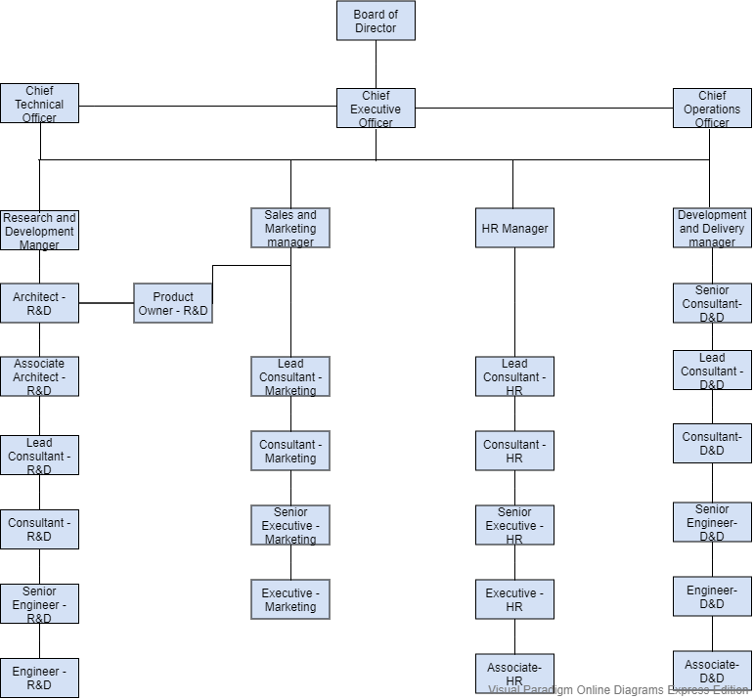

## Focus Area: Innovation / Product Growth aligned with innovativeness

|  |  |
| --- | --- |
| Action Plan 1.1 | Launch 2 new innovative products by 1st May 2020 |
| Resources | Business Analysts, business development consultants |
| Start Date | 1st April 2019 |
| Complete Date | 1st May 2020 |
| Project Manager | R&D Manager, Sales and Marketing manager |

|  |  |
| --- | --- |
| Action Plan 1.2 | Launch / transition to a cloud service model by 1st March 2020 |
| Resources | Cloud Developers |
| Start Date | 1st Jan 2020 |
| Complete Date | 1st March 2020 |
| Project Manager | Development and Delivery Manager |

|  |  |
| --- | --- |
| Action Plan 1.3 | Ensure that 60% of our approved projects are classed as Best Web 2020' by 31st December 2020 |
| Resources | - |
| Start Date | 31st December 2019 |
| Complete Date | 31st December 2020 |
| Project Manager | Sales and Marketing manager |

|  |  |
| --- | --- |
| Action Plan 1.4 | Launch an innovation lab by 31st June 2020 |
| Resources | Latest technology architects and employees |
| Start Date | 31st June 2019 |
| Complete Date | 31st June 2020 |
| Project Manager | R&D Manager |

## Focus Area: People / Culture aligned with respect and employee empowerment

|  |  |
| --- | --- |
| Action Plan 1.1 | Reduce staff attrition to less than 10% per annum by 1st Jan 2020 |
| Resources | HR Employees |
| Start Date | 1st Jan 2019 |
| Complete Date | 1st Jan 2020 |
| Project Manager | HR Manager |

|  |  |
| --- | --- |
| Action Plan 1.2 | Win a Great Place to Work award by 31st Dec 2020 |
| Resources | - |
| Start Date | 31st Dec 2019 |
| Complete Date | 31st Dec 2020 |
| Project Manager | Sales and Marketing Manager |

|  |  |
| --- | --- |
| Action Plan 1.3 | Implement a flexible working programme by 1st Feb 2020 |
| Resources | - |
| Start Date | 20th Jan 2020 |
| Complete Date | 1st Feb 2020 |
| Project Manager | HR Manager |

|  |  |
| --- | --- |
| Action Plan 1.4 | Hire 2 additional product managers by 1st April 2020 |
| Resources | Employees to carry out interview, HR employees |
| Start Date | 1st March 2020 |
| Complete Date | 1st April 2020 |
| Project Manager | HR Manager |

## Focus Area: Processes / Operations aligned with innovativeness

|  |  |
| --- | --- |
| Action Plan 1.1 | Reduce product rejection rate to less than 2% by 1st Jan 2020 |
| Resources | CTO, R&D Manager, Sales and Marketing Manager |
| Start Date | 1st Oct 2019 |
| Complete Date | 1st Jan 2020 |
| Project Manager | CTO, R&D Manager, Sales and Marketing Manager |

|  |  |
| --- | --- |
| Action Plan 1.2 | Implement a rigorous process of auditing our practices by 1st Jan 2020 |
| Resources | Board of Directors |
| Start Date | 1st Nov 2019 |
| Complete Date | 1st Jan 2020 |
| Project Manager | - |

|  |  |
| --- | --- |
| Action Plan 1.3 | Increase sales efficiency to a 20% conversion rate through use of a CRM by 1st March 2020 |
| Resources | CRM Consultants |
| Start Date | 1st Oct 2020 |
| Complete Date | 1st March 2020 |
| Project Manager | CTO |

## 

## Focus Area: Financial Growth aligned with employee empowerment

|  |  |
| --- | --- |
| Action Plan 1.1 | Grow gross revenue to 2 million LKR by 31st Dec 2020 |
| Resources | CEO, COO |
| Start Date | 1st Jan 2020 |
| Complete Date | 31st Dec 2020 |
| Project Manager | CEO |

|  |  |
| --- | --- |
| Action Plan 1.3 | Reduce net costs by 0.25 million LKR by 1st Nov 2020 |
| Resources | CEO |
| Start Date | 1st Jan 2020 |
| Complete Date | 1st Nov 2020 |
| Project Manager | CEO |

## Focus Area: Customer Satisfaction aligned with trust

|  |  |
| --- | --- |
| Action Plan 1.1 | Deliver a customer survey overall satisfaction score of 90% by 1st Jul 2020 |
| Resources | Sales and Marketing team |
| Start Date | 1st May 2020 |
| Complete Date | 1st Jul 2020 |
| Project Manager | Sales and Marketing Manager |

|  |  |
| --- | --- |
| Action Plan 1.2 | Win at Customer Service Excellence award for customer service by 1st Jan 2021 |
| Resources | Sales and Marketing team |
| Start Date | 1st Jan 2020 |
| Complete Date | 1st Jan 2021 |
| Project Manager | Sales and Marketing manager |

|  |  |
| --- | --- |
| Action Plan 1.3 | Attract 3 major customers in Asia Pacific by 30th Sept 2020 |
| Resources | Sales and Marketing team, development team |
| Start Date | 1st May 2020 |
| Complete Date | 30th Sept 2020 |
| Project Manager | Sales and Marketing Manager, Development and Delivery manager |

# Conclusion

Echonlabs is a tech startup with a vision to connect everyone to solutions that increase productivity and efficiency, through innovative solutions. They have four organizational values which are linked to carry on this vision. Namely these values are employee empowerment, knowledge sharing and innovation, trust and respect. Our unanimous observation is that Echonlabs orient themselves in such a way that they can address these values to ultimately succeed their vision.

As an elaboration, among their business strategies the following were specially highlighted. Cost Leadership aligned with respect and trust, Differentiation aligned with trust and innovation. According to these highlighted aspects, they dedicatedly align their values with their strategies. And the same follows through their functional strategies as well. Launch 2 new innovative products by 1st May 2020, Reduce staff attrition to less than 10% per annum by 1st Jan 2020, are some of the examples.

All of these strategies are strategized with their skilled human resources in mind. In other words each action in their action plan has dedicated human resources to perform and a personnel to manage the said human resource.

Finally as the researchers, our opinion on this organization is that they are performing very well in this industry with a straightforward mission in mind that is to provide low-cost premium solutions for businesses to build their online presence and to improve their workflow.

# References

1. Project Management Docs. 2020. Free Human Resource Plan Templates - Project Management Docs. [online] Available at: <[https://www.projectmanagementdocs.com/template/project-planning/human-resource-plan/>](https://www.projectmanagementdocs.com/template/project-planning/human-resource-plan/%3e%20) [Accessed 27 March 2020].
2. Ctb.ku.edu. 2020. Chapter 8. Developing A Strategic Plan | Section 5. Developing An Action Plan | Main Section | Community Tool Box. [online] Available at: <<https://ctb.ku.edu/en/table-of-contents/structure/strategic-planning/develop-action-plans/main>> [Accessed 27 March 2020].
3. Smallbusiness.chron.com. 2020. 10 Most Important Business Objectives. [online] Available at: <<https://smallbusiness.chron.com/10-important-business-objectives-23686.html>> [Accessed 27 March 2020].
4. Study.com. 2020. [online] Available at: <<https://study.com/academy/lesson/functional-strategy-definition-examples.html>> [Accessed 27 March 2020].
5. CEOpedia | Management online. 2020. Functional Strategy. [online] Available at: <<https://ceopedia.org/index.php/Functional_strategy>> [Accessed 27 March 2020].
6. Echonlabs.com. 2020. About | Echonlabs - Web Designing, Mobile Application Development And Enterprise Software Solutions In Sri Lanka. [online] Available at: <<https://www.echonlabs.com/about>/> [Accessed 27 March 2020].